# Normal Curve

1. In a dataset on the prices of houses, the average price was 210 (thousand dollars) with a standard deviation of 20 (thousand dollars). Find the z-score of:
   1. a house with price 270 *3*
   2. a house with price 210 *0*
   3. a house with price 250 *2*
   4. a house with price 180 *-1.5*
2. Example: On which test did Jill perform the best? Hint: Transform each result to a z-score.

|  |  |  |  |
| --- | --- | --- | --- |
| Type of Exam | Jill's score | Average Score | Standard Deviation |
| Personality | 89 | 76 | 14.7 |
| Business Skills | 74 | 67 | 7.3 |
| Computer Skills | 107 | 95 | 11.2 |

*Personality z- score: 0.884 | Business Skills z- score: 0.959 | Computer Skills z- score: 1.071*

1. A computer literacy test was given to 100 secretaries. The mean score was 47 with a standard deviation of 4.7.
   1. If Jill had a z-score of -0.89, what was her actual score? *42.817*
   2. If Bill had a z-score of 2.46, what was her actual score? *58.562*
   3. If Phil had a z-score of -3.79, what was her actual score? *29.187*
2. In a certain distribution, μ=69 and σ=0. What is the z-score of any score in this distribution? Explain your answer.

*No z- score, we can't divide by zero.*

1. Which normal distribution curve has a wider spread, one with μ=4 and σ=2 or one with μ=2 and σ=4?

*The second has a wider spread because the standard deviation makes the spread.*

1. Draw a normal curve that has the following characteristics:
   1. mean=7 and standard deviation=3
   2. mean=3 and standard deviation = 5

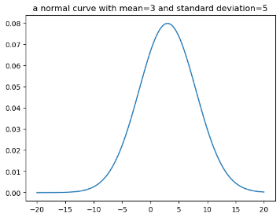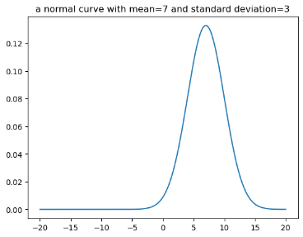

1. Find the percentage of z-scores in a standard normal distribution that are between z=-1.48 and z=2.03.

*0.909*

1. The number of mortgage applications approved by a particular commercial bank is approximately normally distributed with a mean of 15 and a standard deviation of 2 applications per day. If a day is randomly selected, what is the probability that the bank will approve more than 10 applications on that day? What is the probability that on any randomly selected day the bank will approve at most 19 applications?

*10: 0.994*

*19: 0.977*

1. Jill owns a fish hatchery. She finds that the length of the fish is normally distributed with μ=8 and σ=1.2 cm. Approximately what percentage of the fish are more than 8.5cm in length?

*0.338*

1. The life of a certain flashlight battery is normally distributed with mean of 87 hours and a standard deviation of 5.1 hours. Find the probability that a randomly selected battery from this group will last:
   * 1. at most 76 hours. *0.0155*
     2. more than 90 hours. *0.278*
     3. between 85 and 89 hours. *0.3049*
2. A flashlight battery has a mean life of 40 hours and a standard deviation of 5 hours. Find the percentage of batteries that last:
   1. less than 5 hours *0.0*
   2. more than 45 hours *0.1586*

Remember:

* stats.norm.ppf takes a percentage and gives the z-score of the upper limit (on the top)
* stats.norm.cdf takes a z-score and gives the percentage less than (to the left of) that z-score
* The formula allows us to calculate a z-score based on an x (value, data, score) and to calculate an x based on a z-score.
* Draw a picture for every exercise!